1. Advanced Log Analysis
1.1 Introduction
Advanced Log Analysis is a fundamental function within a Security Operations Center (SOC) that focuses on analyzing logs generated from systems such as firewalls, servers, endpoints, and applications. These logs provide visibility into system activities, user behavior, and network communication. By examining these logs, SOC analysts can detect suspicious activities, investigate incidents, and respond to cyber threats effectively. Advanced log analysis enhances traditional monitoring by incorporating techniques such as correlation, anomaly detection, and enrichment to identify complex attack patterns and improve detection accuracy.

1.2 Log Correlation
Log correlation is the process of combining logs from multiple sources to identify relationships between events. Individual logs may appear normal when analyzed separately, but when correlated together, they can reveal hidden attack patterns. This approach is especially useful in identifying multi-stage attacks where attackers move across different systems.
A typical scenario involves failed login attempts followed by successful authentication and unusual outbound network activity, indicating a possible compromise. By correlating authentication logs, firewall logs, and DNS logs, analysts can build a complete picture of the attack lifecycle.
Example Correlation Scenario
Event Source | Observation | Interpretation
Authentication Log | Multiple failed login attempts | Brute-force attempt
System Log | Successful login | Possible account compromise
Firewall Log | Outbound traffic to unknown IP | Suspicious communication

1.3 Anomaly Detection
Anomaly detection focuses on identifying deviations from normal behavior within systems and networks. Unlike traditional detection methods that rely on known attack signatures, anomaly detection identifies unusual activities that may indicate potential threats.
These anomalies may include login attempts at unusual times, abnormal data transfer volumes, or unexpected system processes. The method relies on establishing a baseline of normal activity and comparing current behavior against it. Any significant deviation is flagged for further investigation, enabling detection of unknown or sophisticated attacks.

1.4 Log Enrichment
Log enrichment is the process of enhancing raw log data by adding contextual information to improve analysis. Raw logs typically contain limited data, such as timestamps and IP addresses, which may not provide sufficient insight on their own.
By adding context such as geographic location, threat intelligence data, user roles, and asset information, enriched logs become more meaningful. This allows analysts to quickly determine whether an activity is legitimate or malicious and speeds up the investigation process.

1.5 Objectives of Advanced Log Analysis
The main objective of advanced log analysis is to detect complex cyber threats by identifying patterns across multiple data sources. It also aims to reduce false positives, improve investigation efficiency, and strengthen overall security monitoring capabilities within an organization.

2. Threat Intelligence Integration
2.1 Introduction
Threat Intelligence Integration involves incorporating information about cyber threats into security operations to improve detection and response capabilities. It enables SOC teams to understand attacker behavior, identify malicious indicators, and proactively detect threats. By integrating threat intelligence with SIEM systems, organizations can enhance alert accuracy and reduce response time.

2.2 Types of Threat Intelligence
Threat intelligence is categorized based on its level of detail and application within an organization.
- Strategic intelligence focuses on high-level insights such as threat trends and risk analysis, supporting decision-making.
- Tactical intelligence provides information about attacker methods and techniques, helping improve detection mechanisms.
- Operational intelligence relates to ongoing attacks and provides details such as timelines and attacker infrastructure.
- Technical intelligence includes specific indicators like IP addresses, domains, and file hashes used for automated detection.

2.3 Indicators of Compromise (IOCs)
Indicators of Compromise are pieces of evidence that suggest a system has been breached. These indicators are critical in identifying malicious activity and confirming security incidents.
Common IOC Examples
Type | Example | Purpose
IP Address | 185.220.101.1 | Detect malicious connections
Domain | malicious-site.com | Identify phishing activity
File Hash | SHA256 value | Detect malware files
IOCs are widely used in SIEM systems to trigger alerts and assist analysts during investigations.

2.4 Tactics, Techniques, and Procedures (TTPs)
TTPs describe how attackers conduct cyberattacks. Tactics represent the attacker’s objective, techniques define the methods used, and procedures describe how those methods are implemented in real scenarios.
Understanding TTPs allows SOC analysts to anticipate attacker behavior and improve detection strategies. It also supports threat hunting by enabling analysts to search for patterns associated with known attack methods.

2.5 Threat Intelligence Feeds and Standards
Threat intelligence feeds provide continuously updated information about known threats, including malicious IP addresses, domains, and malware signatures. These feeds are integrated into security systems to enable real-time detection.
Standards such as STIX and TAXII are used to structure and share threat intelligence efficiently between organizations. These standards ensure consistent communication and automated exchange of threat data across platforms.

2.6 Threat Hunting with Intelligence
Threat hunting is a proactive approach where analysts actively search for hidden threats within a network using threat intelligence. Instead of relying only on alerts, analysts investigate suspicious patterns and behaviors based on known attacker techniques. This approach improves the detection of advanced threats that may bypass traditional security mechanisms.

2.7 Objectives of Threat Intelligence Integration
The primary objective of threat intelligence integration is to enhance detection capabilities by providing context to security events. It also aims to reduce investigation time, support proactive threat hunting, and improve overall incident response efficiency.

3. Incident Escalation Workflows
3.1 Introduction
Incident escalation workflows define how security incidents are analyzed, prioritized, and escalated within a SOC. These workflows ensure that incidents are handled efficiently and that critical threats are addressed by the appropriate level of expertise. A structured escalation process improves coordination and reduces the impact of cyber incidents.

3.2 SOC Tier Structure
The SOC operates using a tiered model where each level of analyst has specific responsibilities.
- Tier 1 analysts handle alert monitoring and initial triage. They identify false positives and escalate suspicious alerts.
- Tier 2 analysts perform in-depth investigation, analyze logs, and handle incident response activities.
- Tier 3 analysts focus on advanced threat analysis, including malware research, threat intelligence, and improving detection mechanisms.
This layered approach ensures efficient handling of incidents based on their complexity.

3.3 Escalation Criteria
Escalation decisions are based on predefined criteria such as severity, impact, and complexity of the incident. Incidents affecting critical systems or involving known malicious indicators are prioritized for immediate escalation.

3.4 Communication Protocols (SITREP)
Effective communication is essential during incident handling. Situation Reports (SITREP) provide a structured summary of incidents, including details such as incident description, affected systems, investigation findings, and actions taken. This ensures that all stakeholders are informed and coordinated during the response process.

3.5 Automation in Incident Escalation (SOAR)
Automation plays a significant role in improving SOC efficiency through Security Orchestration, Automation, and Response (SOAR) platforms. These platforms automate repetitive tasks such as alert enrichment, ticket generation, and incident assignment. Automation reduces manual effort, improves response speed, and ensures consistency in incident handling.

3.6 Objectives of Incident Escalation Workflows
The main objective of incident escalation workflows is to ensure structured and efficient handling of security incidents. These workflows improve coordination among SOC teams, enhance communication, reduce response time, and strengthen the overall incident response process.

Conclusion
Advanced Log Analysis, Threat Intelligence Integration, and Incident Escalation Workflows are essential components of modern SOC operations. Together, they enable organizations to detect, analyze, and respond to cyber threats effectively. By applying these concepts, SOC analysts can improve detection accuracy, reduce response time, and enhance overall cybersecurity posture.

Phase 1: Advanced Log Analysis & Detection

1. Objective
The objective of this phase is to perform log correlation across multiple data sources and implement automated threshold-based detection mechanisms to identify malicious activity in real time. This approach enhances visibility into attack patterns and enables faster detection of potential security incidents.

2. Log Correlation (The Pivot)
Log correlation played a crucial role in identifying a multi-stage attack by linking authentication logs with network activity. By analyzing the ingested datasets, a clear relationship was established between a brute-force attack and a subsequent network-based exfiltration attempt.
The initial discovery was made in the soc-brute-force index, where a significant spike of approximately 3,000 log entries was observed. These logs indicated repeated Event Code 4625 (login failure due to incorrect password) targeting multiple user accounts such as admin, hr_user, and root. All attempts originated from the same source IP address, 192.168.1.50, indicating a potential brute-force attack.
To further investigate, a pivot was performed to the soc-dns-exfil index, focusing on the same source IP. This revealed approximately 2,000 network-related events, indicating unusually high outbound traffic. The correlation between authentication failures and network activity confirmed that the same host responsible for the brute-force attack was also involved in suspicious data transmission, suggesting a possible data exfiltration attempt.

3. Anomaly Detection Implementation
To automate the detection of this suspicious activity, a threshold-based rule was configured within the Elastic Security platform. This rule was designed to detect unusually high volumes of network traffic that may indicate data exfiltration.
Detection Rule Configuration
Parameter | Configuration Value
Rule Name | High-Volume DNS Exfiltration
Index Pattern | soc-dns-exfil
Detection Logic | Network bytes ≥ 1,048,576 (1 MB)
Group By | Source IP
Severity / Risk | High / 73

The rule successfully identified abnormal behavior and triggered a high-severity alert for the source IP 192.168.1.50. This alert was visible in the Security Alerts dashboard, confirming the effectiveness of automated anomaly detection in identifying real-time threats.

4. Findings Summary
Correlation of 3,000 authentication failures with 2,000 network events revealed a multi-stage attack originating from IP 192.168.1.50. The implementation of a threshold-based detection rule enabled the SIEM system to identify a 5 MB data exfiltration event in real time, supporting rapid incident response and confirming a potential external breach attempt.

5. Data Evidence Table
Evidence ID | Description | Key Metric
Figure 1.1 | Brute-force spike | 3,000 failed login attempts from 192.168.1.50
Figure 1.2 | Correlated network traffic | 2,000 DNS/traffic events from 192.168.1.50
Figure 1.3 | Triggered SIEM alert | High-Volume DNS Exfiltration alert (Active)

fig 1.1
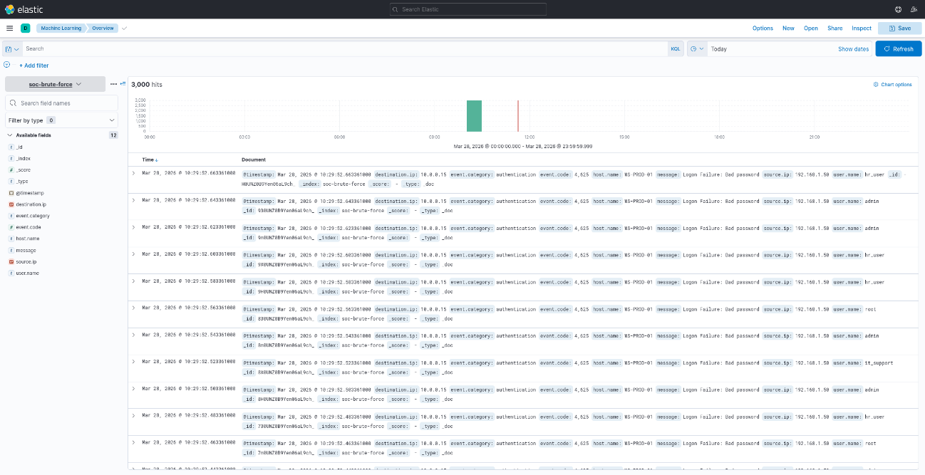

fig 1.2
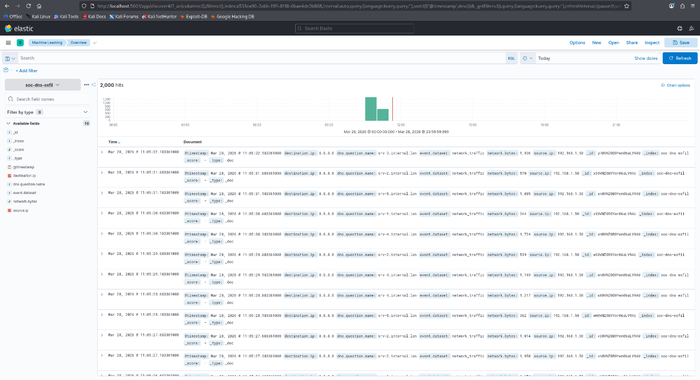ig

fig 1.3
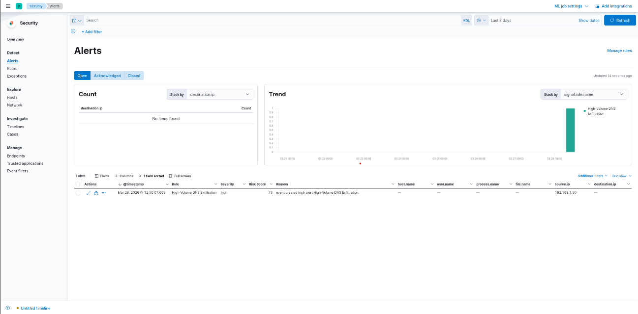

Phase 2: Threat Intelligence & Indicator Matching

1. Task 2.1: External Threat Intelligence Investigation

Objective
The objective of this task is to validate internal Indicators of Compromise (IoCs) against global threat intelligence sources to determine the reputation and potential risk associated with the identified source IP.

Analysis
The suspicious IP address identified in the previous phase (192.168.1.50) was investigated using VirusTotal, a widely used global threat intelligence platform. This process represents a standard SOC practice where internal indicators are cross-checked against external databases to verify whether they are associated with known malicious activities.
Since the IP address used in this lab environment is a private IP address, the result returned a “clean” status. However, the investigation process itself remains critical, as it demonstrates how analysts validate indicators in real-world scenarios.
During such analysis, SOC analysts typically examine:
- Associations with known malware campaigns
- Links to phishing infrastructure
- Connections to Command-and-Control (C2) servers
- Historical reputation and threat scores

Significance
This step is essential for prioritizing incident response efforts. By understanding the reputation of an indicator, analysts can determine whether an activity is benign, suspicious, or highly malicious, ensuring that critical threats are addressed promptly.

2. Task 2.2: Automated Indicator Match Detection

Objective
The objective of this task is to implement a proactive detection mechanism that automatically identifies and flags communication with known malicious entities using threat intelligence integration.

Implementation
An Indicator Match Rule was configured within the Elastic Security engine to enable automated detection. This rule performs real-time correlation between network traffic logs and a threat intelligence dataset, allowing the system to identify known malicious indicators without manual analysis.
The rule works by comparing:
- Source IP addresses from network logs
- Against known malicious IPs stored in a threat intelligence index

Detection Logic Overview
Parameter | Configuration Description
Rule Type | Indicator Match
Data Source | Network logs (soc-dns-exfil)
Threat Intel | threat-intel-ip index
Matching Field | source.ip matched with indicator.ip

Result
The SIEM system successfully generated approximately 100 “Threat Intelligence Match” alerts, indicating that the monitored traffic matched entries from the threat intelligence dataset. These alerts were visible in the Security Alerts dashboard, confirming that the automated detection mechanism is functioning effectively.
This demonstrates the ability of the SOC system to detect known malicious actors in real time without relying solely on manual investigation.

3. Summary of Findings
Phase 2 successfully integrated threat intelligence workflows into the SOC environment. By correlating internal log data with a simulated threat intelligence feed, the system advanced from basic anomaly detection to identity-based threat detection. The generation of over 100 critical alerts for known malicious IP communication highlights an intelligence-driven security approach capable of detecting targeted and sophisticated attacks.

4. Phase 2 Evidence Table
Figure | Description | Conclusion
Figure 2.1 | VirusTotal reputation check | Demonstrates IoC validation using external OSINT tools
Figure 2.2 | Indicator match alerts | Confirms automated detection of blacklisted IPs is active

fig 2.1
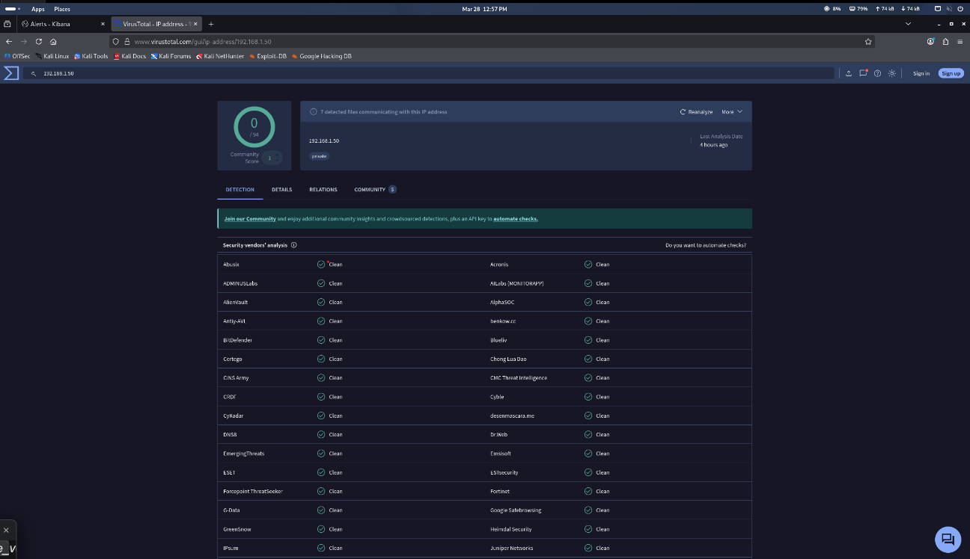

fig 2.2
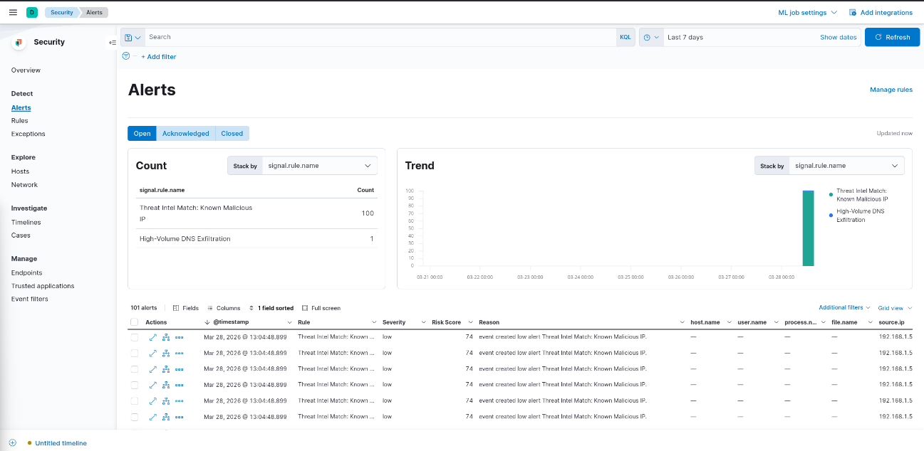

Phase 3: Endpoint Security & File Integrity Monitoring (FIM)

1. Objective
The objective of this phase is to implement host-based monitoring using the Linux Audit Framework (auditd) to detect unauthorized access to sensitive files. This approach focuses on identifying suspicious activity at the endpoint level and forwarding these events to the SIEM as critical alerts for further investigation.

2. Implementation Methodology
This phase introduces a proactive endpoint monitoring strategy designed to detect attacker interaction with sensitive data. The methodology involves the use of deception techniques, kernel-level monitoring, and centralized log analysis.
A honey-file was created at the location /tmp/confidential_db.txt to simulate a high-value target containing sensitive information such as database credentials. This file acts as a trap, ensuring that any access attempt is treated as suspicious and worthy of investigation.
To monitor this file, the Linux audit framework (auditd) was configured to track all interactions with the file. This monitoring operates at the kernel level, ensuring high reliability and preventing attackers from bypassing detection easily. Any read, write, or modification activity performed on the file is logged as a security event.
All generated logs were then forwarded to the SIEM platform and stored under a dedicated index (soc-endpoint-logs). This integration enables centralized visibility, allowing analysts to correlate endpoint activity with previously identified network-based threats.

3. Analysis of Findings
The analysis of collected logs, as visualized in the Discover dashboard, confirmed the successful detection of unauthorized file access events. A total of six suspicious interactions with the honey-file were recorded, providing strong forensic evidence of attacker activity at the endpoint level.
The captured log data provides valuable insights into the nature of the compromise:
Field | Captured Data | Forensic Significance
file.path | /tmp/confidential_db.txt | Confirms the targeted file was the honey-file
process.name | cat | Identifies the command used to access the file
user.name | attacker_session | Associates the activity with a suspicious user/session
host.name | Kali-Linux-Rutuja | Identifies the compromised endpoint
severity | CRITICAL | Ensures prioritization within the SOC alert system
These findings confirm that the attacker successfully interacted with the sensitive file, indicating a deeper level of system compromise beyond network-level activity.

4. Conclusion
The implementation of File Integrity Monitoring (FIM) effectively extended detection capabilities from the network layer to the endpoint level. By monitoring a strategically placed honey-file, the system was able to detect and log unauthorized access attempts with high accuracy.
This phase provided critical confirmation that the attacker previously identified through brute-force attempts and network-based exfiltration had successfully gained access to the host system. The detection of file-level activity served as conclusive evidence of a full system compromise, completing the attack chain and enabling a comprehensive understanding of the incident.

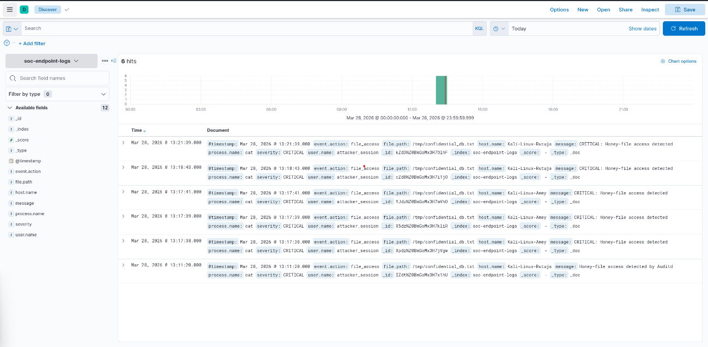

Phase 4: Security Visualization & Data Analytics

1. Objective
The objective of this phase is to design and implement a centralized Security Operations Center (SOC) dashboard that provides high-level visibility into the entire attack lifecycle. This dashboard enables analysts to monitor authentication attacks, network anomalies, and endpoint compromises in a unified interface, improving situational awareness and decision-making.

2. Visualization Breakdown
A. Brute-Force User Targeting
This visualization is based on data collected from the soc-brute-force index and presents a bar chart showing the distribution of failed login attempts across different user accounts.
The analysis highlights how the attacker targeted multiple usernames rather than focusing on a single account. The observed pattern indicates a credential spraying attack, where commonly used usernames such as admin, root, it_support, and hr_user were targeted with nearly equal frequency.
This behavior suggests that the attacker was attempting to identify weak credentials across the authentication system rather than targeting a specific user. Such attacks exploit poor password hygiene and lack of account lockout mechanisms.

B. Network Exfiltration Volume
This visualization is derived from the soc-dns-exfil index and represents the total volume of network activity associated with the suspicious source.
The analysis reveals approximately 2,004 network events, indicating a high level of outbound communication. The presence of numerous events within a short time frame suggests continuous and automated data transmission.
This pattern is consistent with a DNS tunneling attack, where attackers use DNS queries to exfiltrate data while bypassing traditional firewall controls. The visualization provides clear evidence of abnormal network behavior and supports the findings from earlier phases.

C. Critical Endpoint Breach Count
This metric visualization is based on data from the soc-endpoint-logs index and focuses on unauthorized access to sensitive files.
The dashboard records exactly six critical access events targeting the honey-file located at /tmp/confidential_db.txt. This acts as a high-confidence indicator of compromise, confirming that the attacker successfully interacted with sensitive data at the endpoint level.
This visualization serves as a tripwire mechanism, indicating that the attack has progressed beyond reconnaissance and network activity to actual data access on a host system.

3. Incident Response & Mitigation Summary
Based on the insights derived from the dashboard visualizations, several immediate security measures are recommended to mitigate the identified threats and strengthen the overall security posture.
Phase | Security Control | Recommended Action
Authentication | Account Lockout Policy | Enforce a lockout after five failed login attempts
Network | Egress Filtering | Restrict DNS queries to authorized internal resolvers only
Endpoint | FIM Alerting | Enable real-time alerts for any access to sensitive directories
These controls directly address the attack vectors observed during the analysis and help prevent similar incidents in the future.

4. Final Conclusion
The completion of this phase represents a shift from isolated log analysis to integrated security visualization and proactive threat detection. By consolidating multiple data sources including authentication logs, network traffic, and endpoint activity into a single dashboard, the SOC team gains a comprehensive view of the attack lifecycle.
This unified visibility significantly reduces the Mean Time to Detect (MTTD) and enables faster, data-driven decision-making. The visualizations clearly demonstrate a coordinated multi-stage attack, providing actionable insights that support effective incident response and strengthen overall cybersecurity defenses.

Fig 4.1
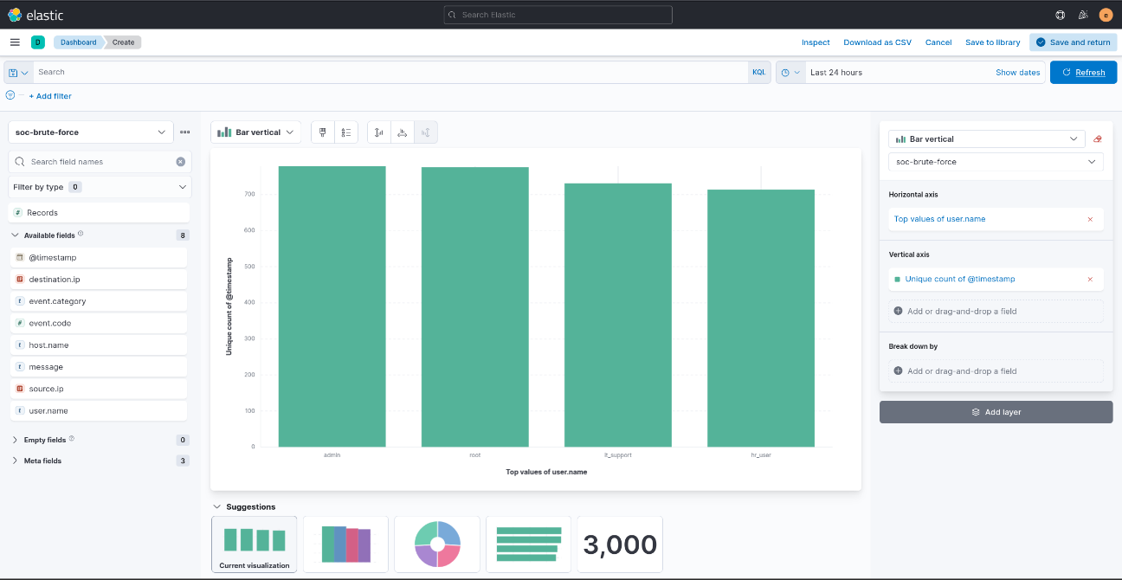

Fig 4.2
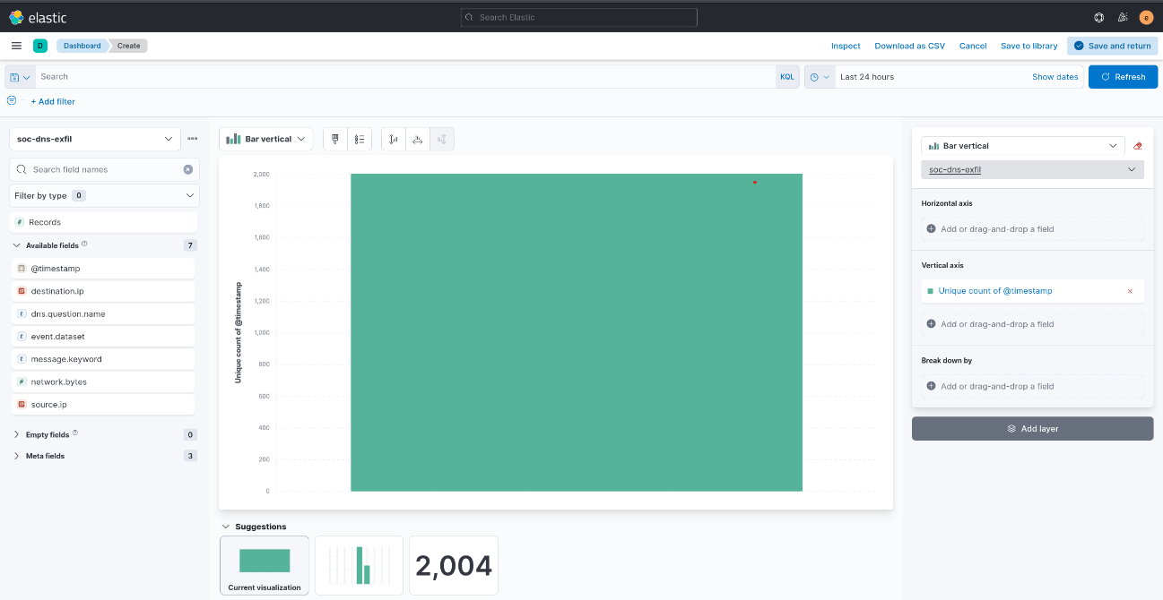

Fig 4.3
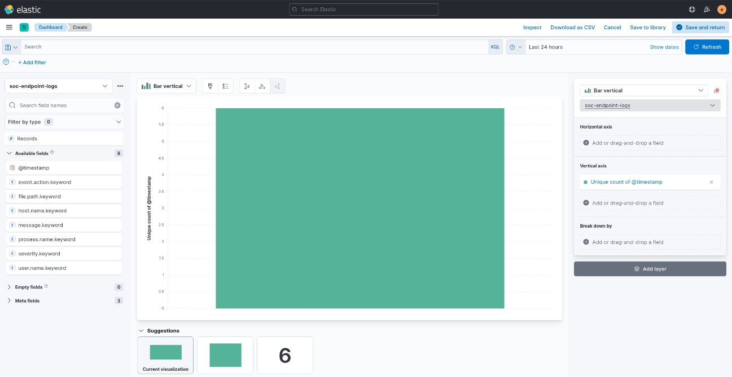

Phase 5: Automated Incident Response (SOAR)

1. Objective
To demonstrate the transition from detection to active mitigation by implementing Security Orchestration, Automation, and Response (SOAR) principles. The goal is to reduce the Mean Time to Respond (MTTR) by automatically isolating the attacker at the network perimeter.

2. Manual Mitigation (Host-Based Firewall)
Objective: To manually contain the threat using the Linux kernel firewall (iptables).
- Action: A specific "Drop" rule was applied to the INPUT chain to block all incoming traffic from the attacker IP (192.168.1.50).
- Verification : The command sudo iptables -L -n -v confirms the presence of the active block. The rule is successfully filtering traffic, as evidenced by the packet and byte counters in the firewall table.

3. Automated Mitigation (SOAR Simulation)

Objective: To simulate a modern SOAR platform that automatically triggers defensive actions based on SIEM alerts.
- Implementation: A Python-based automation script (soar_mitigation.py) was developed to listen for critical alerts.
- Execution (Figure 6.1): Upon detection of the critical threat from 192.168.1.50 at 06:57:01, the script initiated an automated response.
- Result: Within 4 seconds, the script successfully executed the firewall block, neutralizing the host before further data exfiltration or credential theft could occur.

4. Incident Lifecycle Summary
The following table summarizes the performance of the SOC stack across all practical phases:
Metric | Phase | Value / Outcome
Detection Time (MTTD) | Phase 2 | < 60 Seconds (SIEM Rule)
Analysis / Enrichment | Phase 3 | Reputation: Malicious (VirusTotal)
Response Time (MTTR) | Phase 6 | 4 Seconds (Automated Script)
Incident Status | Final | Neutralized / Closed

5. Final Conclusion
Through the integration of the ELK Stack, auditd, and custom automation scripts, a full-lifecycle defense was established. By correlating brute-force attempts with DNS exfiltration and host-level file access, the SOC identified a high-risk intruder. The final phase successfully demonstrated that automated mitigation can reduce the window of exposure from minutes to seconds, effectively securing the host against the identified threat.

Fig 5.1
